The Citizen’s Police Academy (CPA) is an exciting way to learn about police work and how the community can respond to emergencies. Through a well-prepared curriculum, taught once a week for 10 weeks, participants will learn about all aspects of police operations. CPA participants will also meet many of the men and women who serve in the Decatur Police Department as they explain the functions of patrol officers, investigators, and administrators. CPA participants will also learn how officers are trained and how one can protect themselves against crime and hazards. Interesting demonstrations will illustrate the many skills and abilities police officers must have to effectively protect Decatur.

An important and exciting phase of the Academy is the opportunity to leave the classroom and view police work first hand by riding with patrol officers.

Applicants must submit to a limited background investigation by the Decatur Police Department that will include a check of criminal history and driving record. Individuals who do not meet the Georgia Peace Officers Standards and Training Council standards will not be accepted into the CPA program.

Students must be a minimum of 21 years of age by the first day of class. Class space is limited, but a waiting list will be held for future classes should the demand exceed available space. *Preference is given to city residents and business owners.

The Citizen’s Police Academy is an excellent class to take if you want to become informed about police procedures, crime prevention and personal safety. It also gives Decatur residents and those affiliated with Decatur an opportunity to develop working relationships with our Police Department staff. If you are interested in completing an application for the class please contact Sergeant Jennifer Ross at (678) 553-6613 or email her at jennifer.ross@decaturga.com.

THE TENTATIVE DATES OF THE 2014 CPA ARE THURSDAY, SEPTEMBER 11th THRU THURSDAY, NOVEMBER 13th, 2014. CLASS TIMES ARE 7:00 PM – 9:30 PM.

DEADLINE FOR SUBMISSION OF APPLICATIONS IS WEDNESDAY, SEPTEMBER 3RD, 2014.

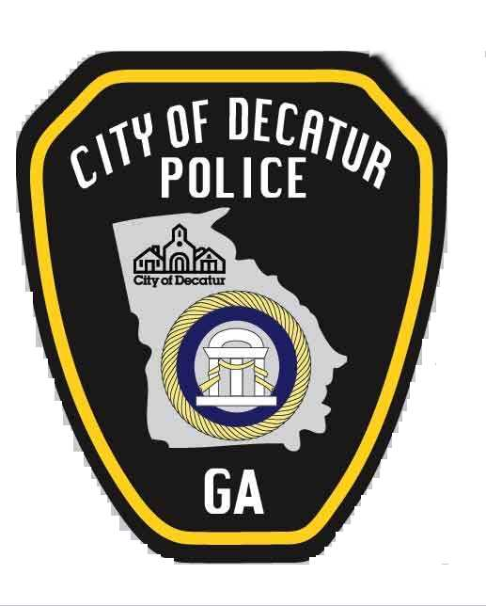

CITY OF DECATUR
CITIZEN’S POLICE ACADEMY
APPLICATION

Please enroll me in the next available session of the Citizen’s Police Academy. I understand I must attend at least 8 of the 10 class sessions and ride on patrol with a police officer to graduate.

TYPE or PRINT NAME________________________________________________

HOME ADDRESS ____________________________________________________

CITY:_________________ STATE:________________ ZIP CODE:________

OCCUPATION:________________________________________________________

ADDRESS:___________________________________________________________

TELEPONE NUMBER: home__________________ work ______________________

Email address: ________________________________________________________

BACKGROUND CHECK CONSENT

I hereby authorize the City of Decatur Police Department to conduct a limited background investigation including a check of criminal history records and driver's history. I understand this check is limited to determining if I meet the basic Georgia Peace Officer Standards and Training Council minimum requirements.

The following is needed to conduct the records check:

Signature:_________________________________________________________

Race:______________________ Sex:_________________________________

Date of Birth:_____________________________________________________

Social Security Number:____________________________________________

Witness:___________________________________________________________

CITY OF DECATUR
CITIZENS POLICE ACADEMY
APPLICANT

LIABILITY WAIVER

The undersigned being over the age of twenty-one (21), does hereby request permission to spend _6-12___ hours with the City of Decatur Police Department as an observer, to include riding in a motor vehicle operated by a City of Decatur police officer. I agree at all times to obey all instructions, orders, and commands given to me by any police officer, firefighter, employee, agent or other agent of the City of Decatur during the time of my participation in this program.

I fully realize and understand that the profession of public safety by its nature is at times dangerous and that I may be subjecting myself to situations that may result in property damage, injury, or death. Further, I understand and acknowledge the potential that property damage, injury, or death may occur as a result of a motor vehicle accident during my time as a ride-along observer. Knowing and understanding these risks, I nevertheless freely accept these risks and accept full responsibility for myself, for any property damage, injury, or death that may occur as a result of the granting of this request.

In consideration of the educational benefit to be received by me and the granting of this request, I, my heirs, and my estate, agree to hold harmless, individually and in their official capacity, any and all City of Decatur Police officials, employees, and agents from all liability in the event of property damage, injury, or death sustained by me during the time I participate as an observer with the City of Decatur Police Department. I, my heirs, and my estate further agree to hold harmless the City of Decatur, Georgia and the City Commissioners individually and in their official capacity from all liability for property damage, injury, or death sustained by me as a result of the granting of this request.

The inclusive dates and times for this request

are________________ to ______________________.

Print Name: __________________________________________________

Signature: ___________________________________________________

Date: ______________________________

Notary Public:____________________________ (Notary Seal)

My Commission Expires:____________________

*Do not write below this line. To be completed by Decatur Police personnel*
******************************************************************************************************

Authorized by: __________________________________ Date: __________________

